**PRACTICAL FILE**

**ON**

**PROBLEM SOLVING USING C PROGRAMMING**

**MASTER OF COMPUTER APPLICATIONS**

**REGULAR PROGRAM**

**Offered by**



***Indira Gandhi Delhi Technical University for Women***

**(Established by Govt. of Delhi Wide Act 09 of 2012)**

**Submitted to :**

Ms.Nidhi Arora

Ms.Bhawna Narwal

**Submitted by :**

Bhavana Sinha

02804092018

MCA 1st sem

**TABLE OF CONTENTS**

|  |  |  |  |
| --- | --- | --- | --- |
| **Sl.no** | **Topic** | **Date** | **Signature** |
|  |  |  |  |
|  |  |  |  |
|  |  |  |  |
|  |  |  |  |
|  |  |  |  |
|  |  |  |  |
|  |  |  |  |
|  |  |  |  |
|  |  |  |  |
|  |  |  |  |
|  |  |  |  |
|  |  |  |  |
|  |  |  |  |
|  |  |  |  |
|  |  |  |  |
|  |  |  |  |
|  |  |  |  |
|  |  |  |  |
|  |  |  |  |
|  |  |  |  |
|  |  |  |  |
|  |  |  |  |
|  |  |  |  |
|  |  |  |  |
|  |  |  |  |
|  |  |  |  |
|  |  |  |  |
|  |  |  |  |
|  |  |  |  |
|  |  |  |  |
|  |  |  |  |
|  |  |  |  |

1. Write a program to print ‘Hello World’ on the screen.

#include<stdio.h>

int main()

{

printf("HELLO WORLD");

getch();

return 0;

}

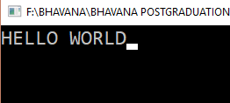

2. Write a program to read an integer input from the user and print the same.

#include<stdio.h>

void main()

{

int a;

printf("enter no.- ");

scanf("%d",&a);

printf("entered no. is %d",a);

getch();

}

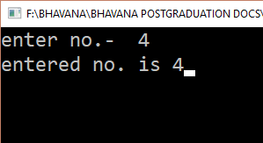

3. Write a program to take two integer inputs and output their sum as the result.

#include<stdio.h>

void main()

{

int a, b,c;

printf("enter two no.s :");

scanf("%d %d",&a,&b);

c=a+b;

printf("sum of the two no.s : %d",c);

getch();

}

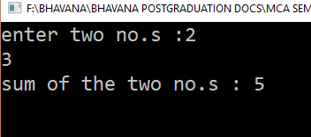

4. Write a program to swap two integers without using a third variable.

#include<stdio.h>

void main()

{

int a,b;

printf("enter two no.s : ");

scanf("%d %d",&a,&b);

a=a+b;

b=a-b;

a=a-b;

printf("now a = %d ",a);

printf("& b = %d ",b);

getch();

}

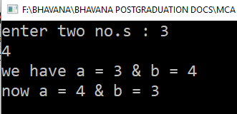

5. Write a program to swap two integers with using a third variable.

#include<stdio.h>

void main()

{

int a,b,temp;

printf("enter two no.s : ");

scanf("%d %d",&a,&b);

printf("we have a = %d ",a);

printf("& b = %d ",b);

printf("\n");

temp=a;

a=b;

b=temp;

printf("now a = %d ",a);

printf("& b = %d ",b);

getch();

}

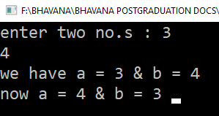

7. Write program(s) to perform following conversions (and vice-versa)

a) Temperature in Celsius to Fahrenheit

b) Height in Centimeters to Feet

#include<stdio.h>

void main()

{

int a;

float ct,ft;

printf("tasks to do:\n");

printf("1.convert to celsius(assuming temp. to be in fahrenheit) \n");

printf("2.convert to fahrenheit(assuming temp. to be in celsius) \n");

printf("choose option ( 1 or 2) :: ");

scanf("%d",&a);

printf("\n");

switch(a){

case 1:

printf("ft= ");

scanf("%f",&ft);

ct=(ft-32)*5/9;

printf("ct= %f",ct);

break;

case 2:

printf("ct= ");

scanf("%f",&ct);

ft=(ct*9/5)+32;

printf("ft= %f",ft);

break;

getch();

}

}

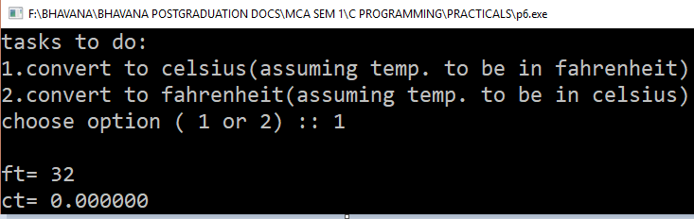

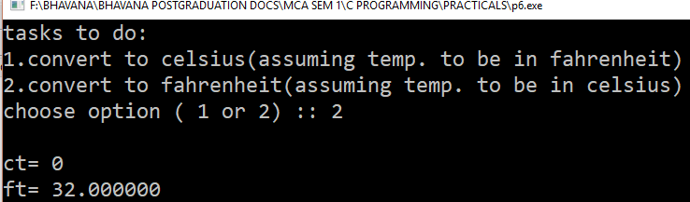

#include<stdio.h>

void main()

{ int a;

float cm,ft;

printf("tasks to do:\n");

printf("1.convert to feet(assuming height to be in centimeters) \n");

printf("2.convert to centimeters(assuming height to be in feet) \n");

printf("choose option ( 1 or 2) :: ");

scanf("%d",&a);

printf("\n");

switch(a){

case 1:

printf("cm= ");

scanf("%f",&cm);

ft=cm/30.48;

printf("ft= %f",ft);

break;

case 2:

printf("ft= ");

scanf("%f",&ft);

cm=ft*30.48;

printf("cm= %f",cm);

break;

getch();

}

}

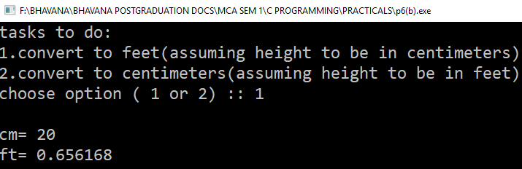

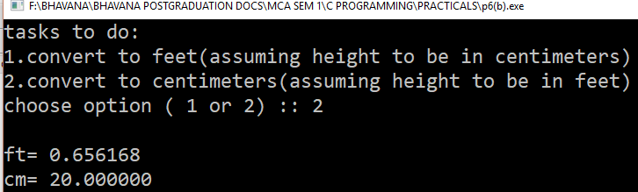

8. Write a program to read an input key stroke (alphabet, numeric or special symbol) and output its equivalent ASCII code.

#include<stdio.h>

void main()

{

char a;

printf("give your input:");

scanf("%c",&a);

printf("\n");

printf("corresponding ascii code w.r.t i/p is : %c=%d",a,a);

getch();

}

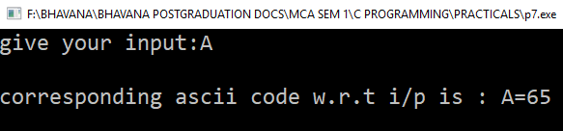

10. Write a program that calculates simple interest given the rate of interest, principal amount and duration (years and months).

#include<stdio.h>

int main()

{

float si,r,p,t;

printf("Enter amt.,rate & time respectively:\n");

printf("p : ");

scanf("%f",&p);

printf("r : ");scanf("%f",&r);

printf("t : ");scanf("%f",&t);

si=(p*r*t)/100;

printf("SI : %f ",si) ;

getch();

return 0;

}

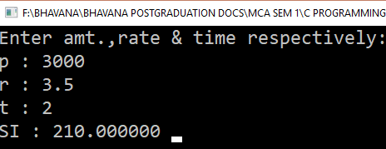

30. Word size of the computer refers to the number of bytes that can be stored in a single memory location. Write a program to find word size of the computer.

#include<stdio.h>

#include<conio.h>

int main()

{

int a,x;

//clrscr();

x=sizeof(a);

printf(" Size of integer : %d\n",sizeof(a));

if(x==2)

{

printf("Word length of host machine is 16 bits");

}

else

{

printf("It is a 32 bit machine");

}

getch();

return 0;

}

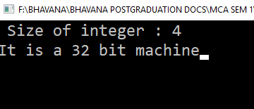

31. Write a program to illustrate working of pointer to pointer.

int main()

{

int var = 789;

// pointer for var

int *ptr2;

// double pointer for ptr2

int **ptr1;

// storing address of var in ptr2

ptr2 = &var;

// Storing address of ptr2 in ptr1

ptr1 = &ptr2;

// Displaying value of var using

// both single and double pointers

printf("Value of var = %d\n", var );

printf("Value of var using single pointer = %d\n", *ptr2 );

printf("Value of var using double pointer = %d\n", **ptr1);

return 0;

}

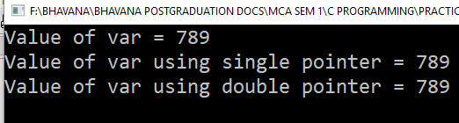

32. Write programs to illustrate pointer arithmetic for different types of pointers.

#include<stdio.h>

void main()

{ int b;

int a=5,*x,a4=6,*p;//declaring the pointer for integer variable

char a1='z',*y,*q;//declaring the pointer for char variable

float a2=2.3,*z;

double a3=3.3,*w;

x=&a;y=&a1;z=&a2,w=&a3,p=&a4,q=&a1;

printf("int x= %d\n",x);//printing the actual value of x

printf("char y= %d\n",y);

printf("float z= %d\n",z);

printf("double w= %d\n",w);

printf("int p=%d\n",p);

printf("char q=%d\n",q);

printf("tasks to do:\n");

printf("1.incrementing a pointer \n");

printf("2.decrementing a pointer \n");

printf("3.addition of a pointer and number \n");

printf("4.subtraction of a pointer and number \n");

printf("5.differencing between two pointers \n");

printf("6.comparison between two pointers \n");

printf("choose option ( 1,2,3,4,,5 or 6) :: ");

scanf("%d",&b);

printf("\n");

switch(b){

case 1: x++;

printf("x++= %d\n",x);//the value gets incremented by 4 bytes because the size of one int variable is 4 bytes

y++;

printf("y++= %d\n",y);

z++;

printf("z++= %d\n",z);

w++;

printf("w++= %d\n",w);

break;

case 2: x--;

printf("x--= %d\n",x);//the value gets decremented by 4 bytes and changes back to the original value

y--;

printf("y--= %d\n",y);

z--;

printf("z--= %d\n",z);

w--;

printf("w--= %d\n",w);

break;

case 3: x=x+3;

printf("x+3= %d\n",x);//value is incremented by 3 i.e size of datatype* 3 is added

y=y+3;

printf("y+3= %d\n",y);

z=z+3;

printf("z+3= %d\n",z);

w=w+3;

printf("w+3= %d\n",w);

break;

case 4: x=x-3;

printf("x-3= %d\n",x);//value is decremented by 3

y=y-3;

printf("y-3= %d\n",y);

z=z-3;

printf("z-3= %d\n",z);

w=w-3;

printf("w-3= %d\n",w);

break;

case 5: printf("x-p=%d\n",x-p);

printf("*x-*p=%d\n",*x-*p);

break;

case 6:

if(x==p)printf("x and p point to the same location\n") ;

else if(x!=p)printf("x and p do not point to the same location\n") ;

if(y==q)printf("y and q point to the same location\n") ;

else if(y!=q)printf("y and q do not point to the same location\n") ;

break;

default: printf("option chosen is not correct");

}

}

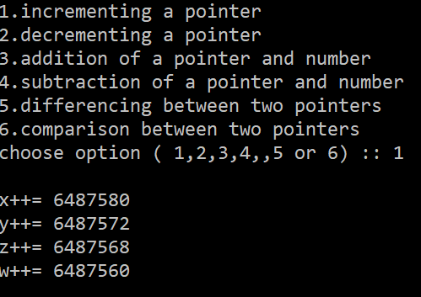

33. Write a program to find size of various types of pointers (int, float, char)? What are the factors on which size depends?

#include <stdio.h>

void main()

{

printf("\nsize of integer variable: %d",sizeof(int));

printf("\nsize of character variable: %d",sizeof(char));

printf("\nsize of float variable: %d",sizeof(float));

printf("\nsize of double variable: %d",sizeof(double));

printf("\nsize of long integer variable: %d",sizeof(long int));

printf("\n");

printf("\nsize of char pointer: %d" ,sizeof(char*));

printf("\nsize of int pointer: %d" ,sizeof(int*));

printf("\nsize of float pointer: %d" ,sizeof(float*));

printf("\nsize of long int pointer: %d" ,sizeof(long int*));

printf("\nsize of double pointer: %d\n" ,sizeof(double*));

printf("\n");

printf("~~~ output for the size of pointer variables depends on the system architecture, but each type of pointer will take same memory space ~~~");

}

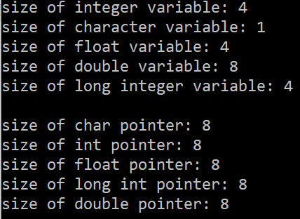

34. Write a program to input a string and display the same as output.

#include<stdio.h>

void main()

{

char name[10];

printf("enter your name:");

scanf("%s",name);

printf("\nname entered is : %s",name);

}

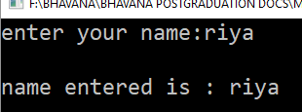

35. Write a program to calculate length of a string.

#include<stdio.h>

#include<string.h>

int main()

{

char name[10];int a;

printf("enter your name:");

scanf("%s",name);

printf("\nname entered is : %s",name);

a=strlen(name);

printf("\n string length=%d",a);

return 0;

}

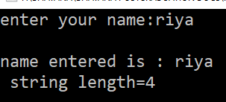

36. Write a program to compare two strings.

#include<stdio.h>

#include<string.h>

int main()

{

char string1[]="jerry";

char string2[]="ferry";

int i,j,k;

i=strcmp(string1,"jerry");

j=strcmp(string1,string2);

k=strcmp(string1,"jerry boy");

printf("\ni=%d,j=%d and k=%d",i,j,k);

if(i==0)printf("\nboth strings being compared are same");

else printf("\nboth strings being compared are not same");

if(j==0)printf("\nboth strings being compared are same");

else printf("\nboth strings being compared are not same");

if(k==0)printf("\nboth strings being compared are same");

else printf("\nboth strings being compared are not same");

return 0; }

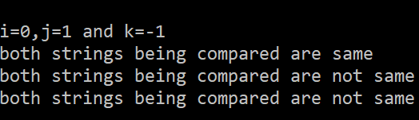

37. Write a program to copy one string into another.

#include<stdio.h>

#include<string.h>

int main()

{

char source[]="Hello";char target[10];

strcpy(target,source);

printf("\n source string= %s",source);

printf("\n target string found by copying source = %s",target);

return 0;

}

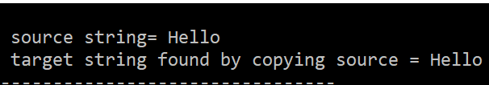

38. Write a program to reverse a given input string.

#include <stdio.h>

#include <string.h>

int main()

{

char arr[100];

printf("Enter a string to reverse: ");

gets(arr);

printf("entered string:");

puts(arr);

strrev(arr);

printf("\nReverse of the string is \n%s\n", arr);

return 0;

}

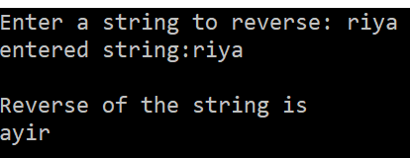

39. Write a program to concatenate a string into another string.

#include<stdio.h>

#include<string.h>

int main()

{

char source[]=" Folks!";char target[]="Hello";

strcat(target,source);

printf("\n source string= %s",source);

printf("\n target string found by concatenating source = %s",target);

return 0;

}

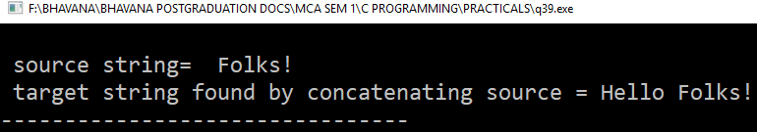

40. Write program(s) to illustrate for various types of storage classes.

#include<stdio.h>

int main()

{

auto int i=1;

{

auto int i=2;

{

auto int i=3;

printf("i= %d\n",i);

}

printf("i= %d\n",i);

}

printf("i= %d\n",i);

return 0;

}

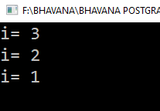

#include<stdio.h>

int main()

{

register int i;

for(i=1;i<10;i++)

printf("%d\n",i);

return 0;

}

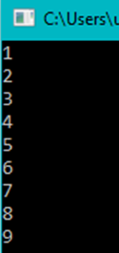

#include<stdio.h>

void increment();

int main()

{

increment();

increment();

increment();

return 0;

}

void increment()

{

static int i=1;

printf("%d\n",i);

i=i+1;}

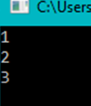

#include<stdio.h>

int i;

void increment();

int main()

{

printf("%d\n",i);

increment();

increment();

return 0;

}

void increment()

{

i=i+1;

printf("%d\n",i);

}

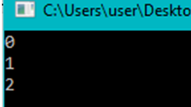

41. Write a program that calculates area of a circle using PI as macro.

#include<stdio.h>>

# define PI 3.14

int main()

{

int r;

printf("enter radius:");

scanf("%d",&r);

double area;

area=PI*r*r;

printf("Area is :%lf",area);

return 0;

}

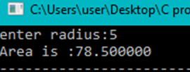

42. Illustrate pointer to structure using a program.

#include<stdio.h>

struct emp

{

char name[10];

int id;

int salary;

};

int main()

{

struct emp e={"surabhi",47,1000.0};

struct emp *ep;

ep= &e;

printf("name of the employee is :%s\n",ep->name);

printf("id is :%d\n",ep->id);

printf("salary is :%d",ep->salary);

return 0;

}

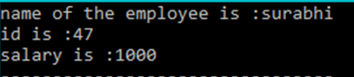

43. Write a function that takes two end points of line segment as input and returns its slope and mid-point.

#include<stdio.h>

void func();

int main()

{

printf("mid point of a line and slope of the line is :\n");

func();

return 0;

}

void func()

{

float x1, y1,s1,s2,x2,y2;

float m1,m2,slope;

printf("enter x1 coordinate :");

scanf("%f",&x1);

printf("enter y1 coordinate :");

scanf("%f",&y1);

printf("enter x2 coordinate :");

scanf("%f",&x2);

printf("enter y2 coordinate :");

scanf("%f",&y2);

printf("(x1,y1)=(%f,%f)\n",x1,y1);

printf("(x2,y2)=(%f,%f)\n",x2,y2);

m1=(x1+x2)/2;

m2=(y1+y2)/2;

printf("midpoint = (%f,%f)\n",m1,m2);

s1=x2-x1;

s2=y2-y1;

slope=s2/s1;

printf("slope is %f",slope);

}

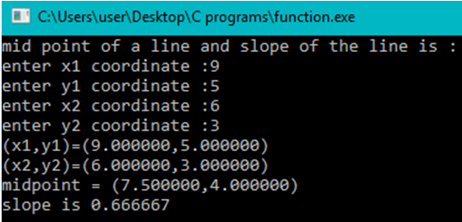

44. Write a program to read a text file as input and count number of characters, words and lines in the file.

#include<stdio.h>

int main()

{

FILE *f;

char ch;

int character=0,words=0,line=0;

f=fopen("cp.txt","r");

while(1)

{

ch=fgetc(f);

if(ch==EOF)

break;

character++;

if(ch=='\n')

line++;

if(ch==' '||ch=='\n')

words++;

}

fclose(f);

printf("characters are :%d\n",character);

printf("lines are :%d\n",line);

printf("words are :%d",words);

return 0;

}

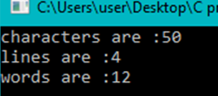

45. Write a program to copy a source text file into a target text file.

#include<stdio.h>

int main()

{

FILE *f,*t;

char ch;

int character=0,words=0,line=0;

f=fopen("cp.txt","r");

t=fopen("tar.txt","w");

while(1)

{

ch=fgetc(f);

if(ch==EOF)

break;

else

fputc(ch,t);

}

fclose(f);

fclose(t);

return 0;

}

46. Write a program to read and write a file using following combinations of functions:

a) fgetc( ) and fputc( )

b) fprintf( ) and fscanf( )

c) fgets( ) and fputs( )

d) fread( ) and fwrite( )

#include<stdio.h>

#include<stdlib.h>

int main()

{

FILE *fs,*ft,*bs,*bt;

struct emp

{

char name[20];

int id;

int salary;

};

struct emp e;

fs=fopen("demo.txt","r");

ft=fopen("demo1.txt","w");

if(fs==NULL)

{

perror("can't open");

fclose(ft);

exit(1);

}

char ch;

char str[10];

while(1)

{

ch=fgetc(fs);

if(ch==EOF)

exit(2);

fputc(ch,ft);

}

while((fgets(str,20,fs))!=NULL)

fputs(str,ft);

bs=fopen("binn.dat","rb");

bt=fopen("binn1.dat","wb");

if(bs==NULL)

{

perror("can't open");

fclose(bt);

exit(3);

}

while(fscanf(bs,"%s,%d,%d",&e.name,&e.id,&e.salary)!=EOF)

{

fprintf(bt,"%s\n,%d\n,%d",e.name,e.id,e.salary);

}

while(fread(&e,sizeof(e),1,bs)==1)

{

fwrite(&e,sizeof(e),1,bt);

}

fclose(fs);

fclose(bs);

return 0;

}

Write a program to determine all the pythagorian triplets in a given range.

#include<stdio.h>

int main()

{

int a,b,i,j,k;

printf("Enter the range:");

scanf("%d %d",&a,&b);

for(i=a;i<=b;i++)

{

for(j=i;j<=b;j++)

{

for(k=j;k<=b;k++)

{

if(k*k==i*i+j*j)

{

printf("pythagorian triplets are:%d , %d , %d\n",i,j,k);

}

}

}

}

return 0;

}

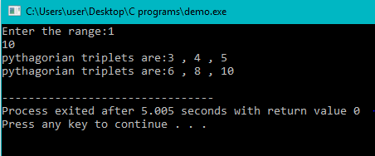

145=1!+4!+5!=145

Write a program to print all no of this kind between a given range.

#include<stdio.h>

int main()

{

int a, b, i,n,j,temp,sum,fact;

printf("enter the range:");

scanf("%d %d",&a,&b);

for(i=a;i<=b;i++)

{

temp=i;

sum=0;

while(temp!=0)

{

fact=1;

n=temp%10;

for(j=1;j<=n;j++)

{

fact=fact*j;

}

sum=sum+fact;

temp=temp/10;

}

if(sum==i)

{

printf("%d",i);

}

}

return 0;

}

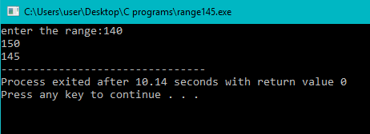

122=144 and 212=441

Write a program to find out such no in a given range.

#include<stdio.h>

int reverse(int num)

{

int rev=0 ,mod;

while(num>0)

{

mod=num%10;

rev=(rev*10)+mod;

num=num/10;

}

return rev;

}

int main()

{

int a,b,i,num,sq,revsq,rev;

printf("enter the range :");

scanf("%d %d",&a,&b);

for(i=a;i<=b;i++)

{

num=i;

rev=reverse(num);

sq=num*num;

revsq=rev*rev;

if(sq==reverse(revsq))

{

printf("square of %d is :%d\n",num,sq);

printf("square of %d is :%d\n",rev,revsq);

}

}

return 0;

}

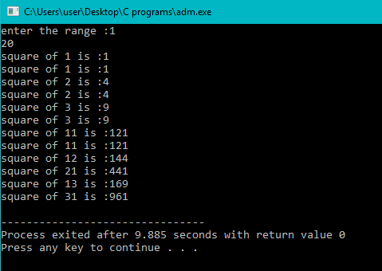

Write a program to print the truth table for xy+z

#include<stdio.h>

void main()

{

int x,y,z;

printf("X\tY\tZ\tXY+Z\n");

for(x=0;x<=1;++x)

for(y=0;y<=1;++y)

for(z=0;z<=1;++z)

{

if(x*y+z==2)

printf("%d\t%d\t%d\t1\n",x,y,z);

else

printf("%d\t%d\t%d\t%d\n",x,y,z,x*y+z);

}

getch();

}

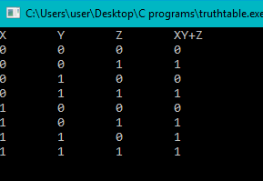

Write a program to find the divisors of a given no.

#include<stdio.h>

int main()

{

int n,i;

printf("enter a number :");

scanf("%d",&n);

for(i=1;i<=n;i++)

{

if(n%i==0)

{

printf("Divisor is :%d\n",i);

}

}

return 0;

}

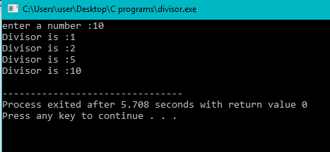

Write a program to check that the square root of a no is prime or not.

#include<stdio.h>

#include<math.h>

int main()

{

int n,x,i,flag=0;

printf("Enter any number: ");

scanf("%d",&n);

x=sqrt(n);

printf("square root is %d ",x);

for(i=2;i<=x/2;i++)

{

if(x%i==0)

{

flag=1;

break;

}

}

if(flag==0)

printf("\n number is prime");

else

printf("\n number is not prime");

return 0;

}

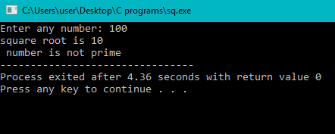

Write a program to input a no and print its digits in words.

#include<stdio.h>

int main()

{

int num=0,n;

printf("enter any number :");

scanf("%d",&n);

while(n != 0)

{

num = (num * 10) + (n % 10);

n=n/10;

}

while(num != 0)

{

switch(num % 10)

{

case 0:

printf("Zero ");

break;

case 1:

printf("One ");

break;

case 2:

printf("Two ");

break;

case 3:

printf("Three ");

break;

case 4:

printf("Four ");

break;

case 5:

printf("Five ");

break;

case 6:

printf("Six ");

break;

case 7:

printf("Seven ");

break;

case 8:

printf("Eight ");

break;

case 9:

printf("Nine ");

break;

}

num = num / 10;

}

return 0;

}

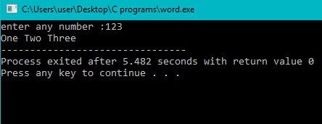

Given it was Monday on 1st Jan 1900. Write a program to find what is the day on 1st Jan of given year.

#include<stdio.h>

void main()

{

int yr, ref_yr=1900, diff, leapyr, normalyr, totald, day;

printf("Enter a year:- ");

scanf("%d", &yr);

diff=yr-ref_yr;

leapyr=diff/4;

normalyr=diff-leapyr;

totald=((normalyr*365)+(leapyr*366));

day=totald%7;

if (day==0)

printf("\nMonday\n");

else if (day==1)

printf("\nTuesday\n");

else if (day==2)

printf("\nWednesday\n");

else if (day==3)

printf("\nThursday\n");

else if (day==4)

printf("\nFriday\n");

else if (day==5)

printf("\nSaturday\n");

else if (day==6)

printf("\nSunday\n");

}

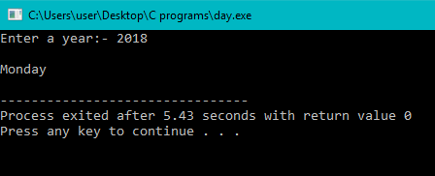

Write a program to count the no of occurrences of a given no in a array.

#include<stdio.h>

int main()

{

int n,i,count=0,x,j;

int arr[50];

printf("enter the no of elements in an array:");

scanf("%d",&x);

printf("enter the elements:");

for(j=0;j<x;j++)

scanf("%d",&arr[j]);

printf("enter the number to find its occurence:");

scanf("%d",&n);

for(i=0;i<x;i++)

{

if(n==arr[i])

{

count++;

}

}

printf("occurences of %d is:%d",n,count);

return 0;

}

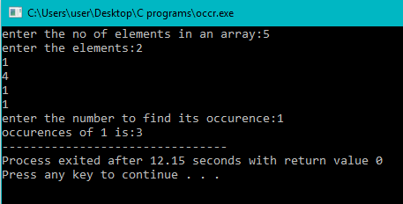

38. Write a program to find the age of the person by the given DOB.

#include<stdio.h>

int main()

{

int tdate,tmonth,tyear,pdate,pyear,pmonth,year,month,day;

printf("enter the DOB of the person -\ndate month year:");

scanf("%d\n %d\n %d",&pdate,&pmonth,&pyear);

printf("enter current -\ndate month year:");

scanf("%d\n %d\n %d",&tdate,&tmonth,&tyear);

int m[] = { 31, 28, 31, 30, 31, 30, 31, 31, 30, 31, 30, 31 };

if (pdate > tdate)

{

tdate = tdate + m[pmonth - 1];

tmonth = tmonth - 1;

}

if (pmonth > tmonth)

{

tyear = tyear - 1;

tmonth = tmonth + 12;

}

year=tyear-pyear;

month=tmonth-pmonth;

day=tdate-pdate;

printf("age is :%dyear\n%dmonth\n%ddays",year,month,day);

return 0;

}

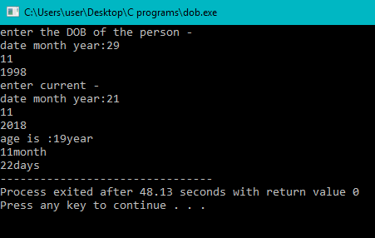

Write a program to find the sum of given series:

1+x2/1!+x4/2!+x6/3!........+x2n/n!

#include<stdio.h>

#include<math.h>

int main()

{

int x,i,fact=1,j,powr;

float sum=0.0;

printf("enter the value of x :");

scanf("%d",&x);

for(i=0,powr=0;powr<=10;i++,powr=powr+2)

{

for(j=powr;j>=1;j--)

fact=fact*j;

sum=sum+ (pow(1,i)*(pow(x,powr)/fact));

}

printf("SUM OF THE SERIES IS :%f",sum);

return 0;

}

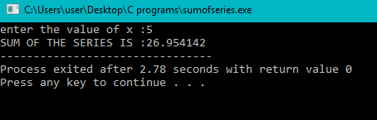

40. Write a program to add the no of days or months in a given date.

#include <time.h>

#include <stdio.h>

int main() {

int y = 1980;

int m = 2;

int d = 5;

int skip = 40;

// Represent the date as struct tm.

// The subtractions are necessary for historical reasons.

struct tm t = { 0 };

t.tm_mday = d;

t.tm_mon = m-1;

t.tm_year = y-1900;

// Add 'skip' days to the date.

t.tm_mday += skip;

mktime(&t);

// Print the date in ISO-8601 format.

char buffer[30];

strftime(buffer, 30, "%Y-%m-%d", &t);

puts(buffer);

}

